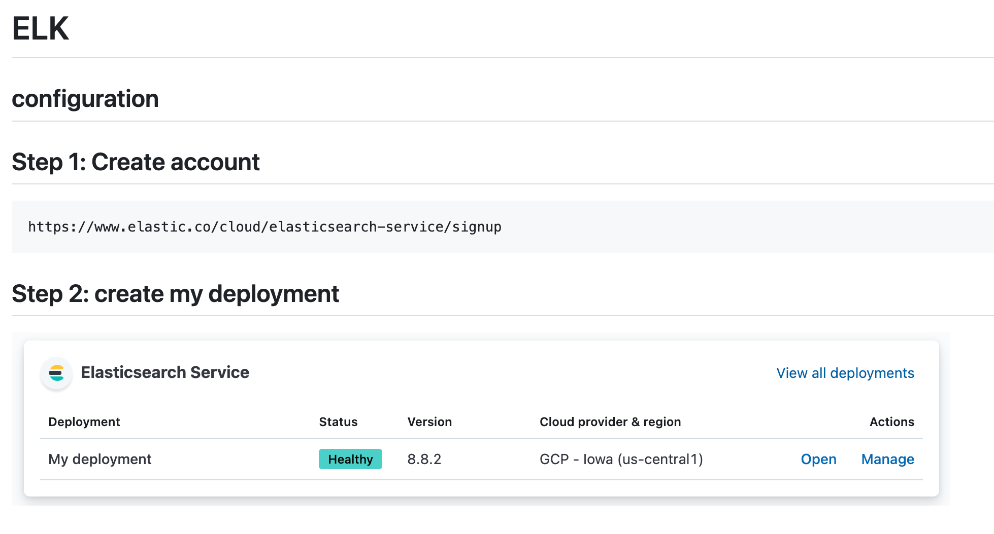

## **Step3: click on Manage ->security->reset password**

You will get username and password

**In kubernetes**

Step 1: Metrics server

kubectl apply -f<https://github.com/kubernetes-sigs/metrics-server/releases/latest/download/components.yaml>

Step2: curl -L -O [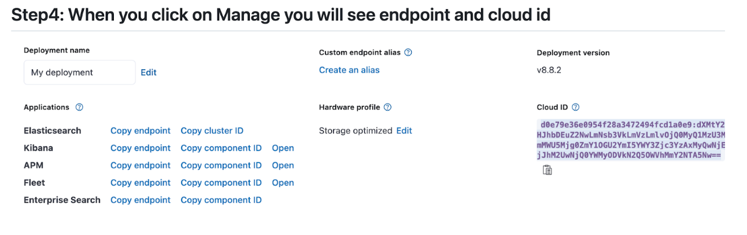https://raw.githubusercontent.com/elastic/beats/8.13/deploy/kubernetes/metricbeat-kubernetes.yaml](https://raw.githubusercontent.com/elastic/beats/8.13/deploy/kubernetes/metricbeat-kubernetes.yaml)

Add the authentication information in metricbeat-kubernetes.yaml inside env.

copy username and password from manage->security->reset password, get cloudid & elasticsearch endpoint paste above

=============

**Another option is below:**

curl -L -O https://raw.githubusercontent.com/elastic/beats/8.14/deploy/kubernetes/filebeat-kubernetes.yaml

Kubectl apply -f filebeat-kubernetes.yaml (paste authentication information before applying) filebeat-kufilebeat-kubernetes.yaml

bernetes.yaml

Please delete ELK deployment after practice or else you will be charged after 14 days.

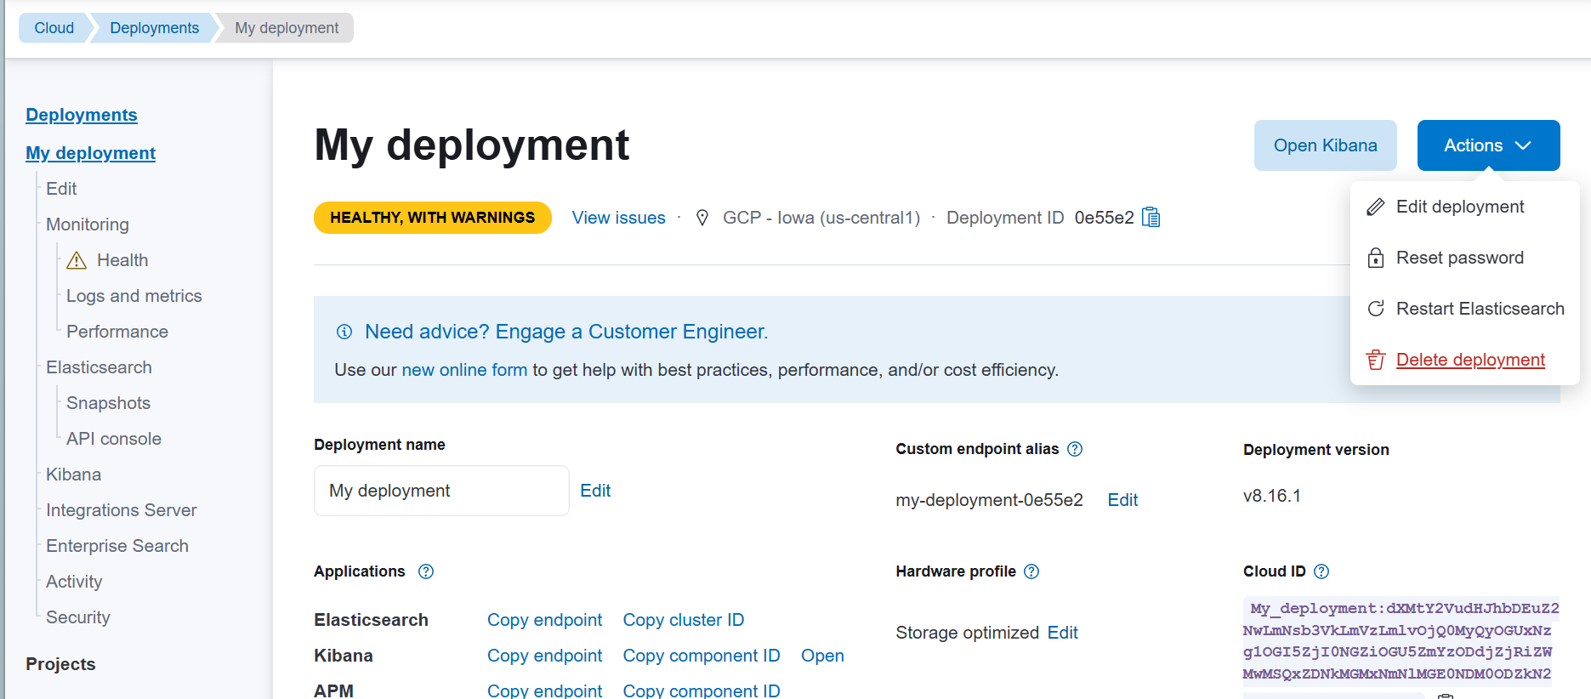

Click on Actions-> delete deployment.

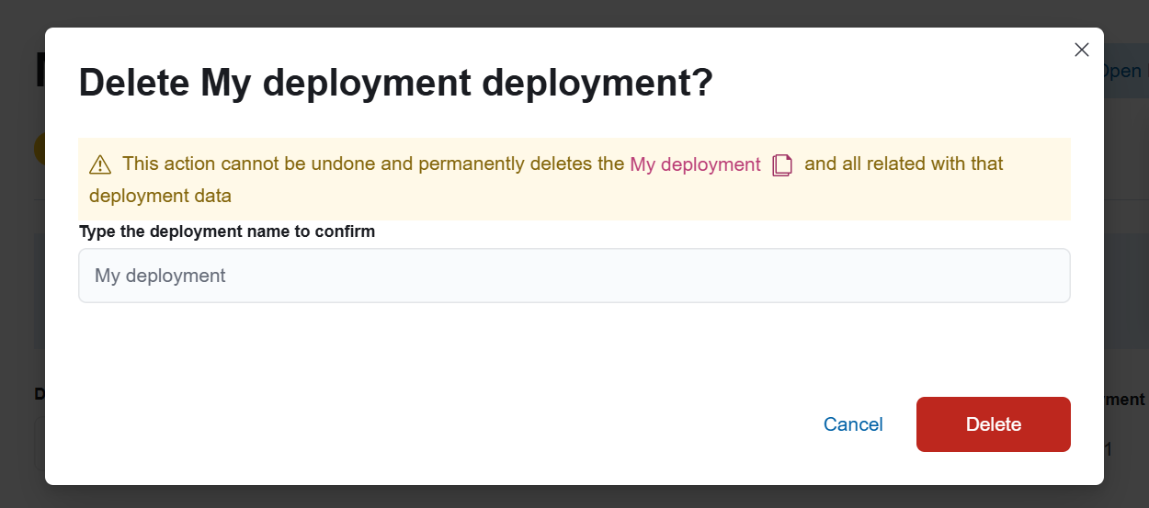

Click on delete again.

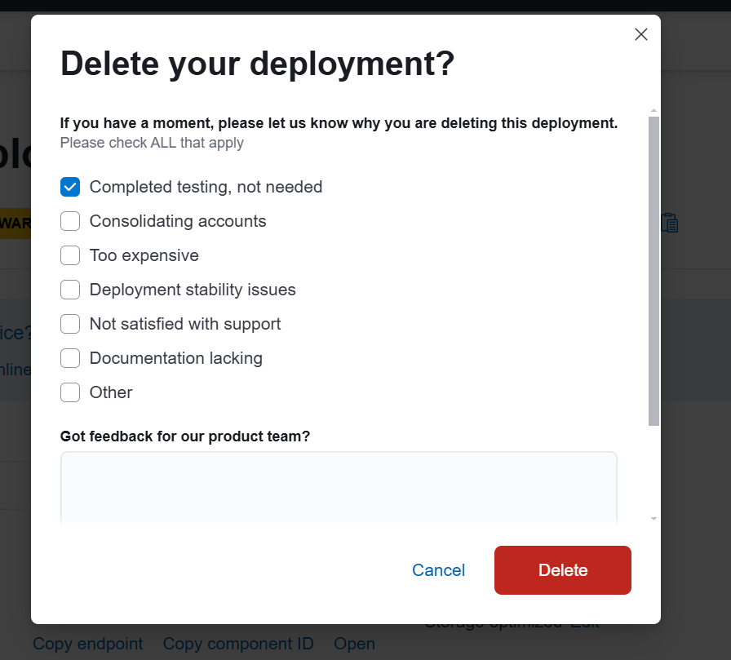

Click on Delete again.